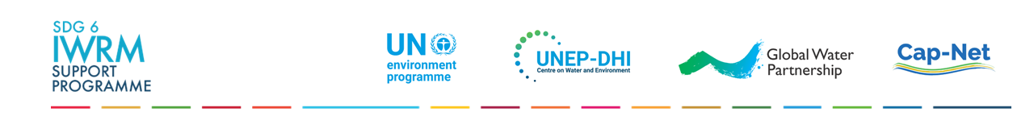
SDG INDICATOR 6.5.1: MONITORING GUIDE
DEGREE OF INTEGRATED WATER RESOURCES MANAGEMENT (IWRM) IMPLEMENTATION

Table of Contents
1 ROLES AND RESPONSIBILITIES: FOCAL POINTS 1
2 AVAILABLE SUPPORT 1
3 STAKEHOLDER CONSULTATION PROCESS 1
4 SURVEY OVERVIEW AND UPDATING THE SURVEY 3
4.1 Survey Overview 3
4.2 Updating the Survey 4
5 SUBMISSION PROCESS, QUALITY ASSURANCE, TIMELINE 5
6 AFTER SUBMISSION 5
ANNEXES 6
ANNEX 1: SUMMARY OF OPTIONAL SUPPORTING MATERIAL 6
ANNEX 2: 6.5.1 QUESTION LINKS TO OTHER SDG TARGETS 7
ANNEX 3: SURVEY DIFFERENCES BETWEEN ROUNDS 8

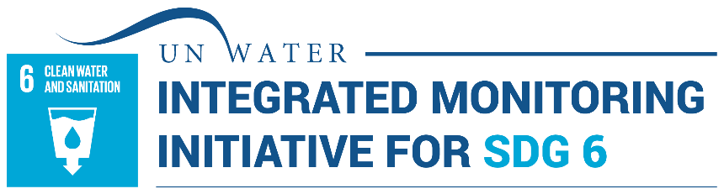

This guide provides an overview of the processes for completing and submitting the SDG indicator 6.5.1 survey (2026 version). This guide should be read by all SDG indicator 6.5.1 Focal Points and supporting Focal Points. The survey and this guide are available in English, French, Spanish, Arabic, Portuguese, Russian, and Chinese. Additional (optional) supporting materials are referenced from the text, and a summary table of these can be found in Annex 1. All materials are available from the IWRM Data Portal.

ROLES AND RESPONSIBILITIES: FOCAL POINTS
The SDG indicator 6.5.1 Focal Point(s) has overall responsibility for coordinating the monitoring process, including stakeholder consultation (see section 3), and submitting draft and final surveys to the United Nations Environment Programme (UNEP), as the custodian agency for the indicator (see section 5). In most countries, Focal Points are affiliated with the ministry responsible for water resources management, although sometimes they are from the National Statistical Office (NSO), Ministry of Planning, Ministry of Foreign Affairs, or similar. In such cases, it is highly recommended that a ‘supporting’ Focal Point is nominated that is affiliated with the ministry for water resources (or similar). The Focal Point will likely work with colleagues in an ‘indicator team’ and may engage or appoint a ‘facilitator’ to run consultation processes (see section 3).

AVAILABLE SUPPORT
Most countries are expected to have the capacity to complete and submit the 6.5.1 survey, drawing on the available supporting materials (see Annex 1), as needed. In addition, any queries can be directed to the SDG 6.5.1 IWRM Help Desk, hosted by UNEP, at iwrmsdg651@un.org. Upon request, the Help Desk can provide support to the Focal Points on matters such as interpretation of questions and thresholds, the appropriate level of stakeholder engagement, and support with submissions.
In 2026, only a limited number of countries will receive technical/financial assistance, through Stage 1 of the SDG 6 Support Programme, to hold stakeholder consultations for reporting on indicator 6.5.1 . These countries have been pre-selected on a needs basis, considering strength of submissions in previous rounds. Countries that have not been pre-selected for Stage 1 support are still welcome to contact the Help Desk throughout their reporting process to ask for guidance.

STAKEHOLDER CONSULTATION PROCESS
To ensure a robust and accurate survey, a stakeholder engagement process to complete the survey is strongly encouraged. The extent of stakeholder consultation should be appropriate within the national context, given time and resource constraints. This may range from key ministries responsible for, or engaged in, various aspects of water resources management, to non-government organisations, the private sector, and academia.
Experience from previous rounds tells us that countries have found the consultation process useful in developing a shared understanding of key issues and priorities among various stakeholders. Stakeholder engagement also makes the completed survey a more useful diagnostic tool for further discussions and planning (see section 6).
While a broad stakeholder consultation might not be feasible in all countries, the following guidance should be considered to ensure a sufficient stakeholder consultation process:
- Preparation: Start by clarifying who will organise and lead the stakeholder consultation. This can be done directly through the Focal Point or a small team appointed by them including for example, government stakeholders across relevant sectors, such as environment, agriculture and economy.
- Updating the survey: Once a group has been identified and a first presentation meeting has been held, the two following approaches, or a blend of both approaches, can be used to update the SDG 6.5.1 survey:
  - in series: consecutive drafts developed with different stakeholders. For example, a first draft may be developed by the Focal Point and immediate colleagues, a second draft discussed within a group of government institutions, and a third draft endorsed by other stakeholders.
  - in parallel: different stakeholders fill out the survey, responses are analysed by the Focal Point and colleagues, then all parties discuss to reach consensus on scores.
- Format: stakeholder consultations can be held in-person, online, or a blend of both.
- Best practices: make the consultation process inclusive, fair, consensus-based, and transparent.
As various questions in the 6.5.1 survey relate to different aspects of water resources use and management, it is preferable that Focal Points responsible for other SDG 6 indicators, and other water-related indicators, are given the opportunity to participate in completing the survey. Reporting on all SDG 6 indicators is coordinated by UN-Water through the Integrated Monitoring Initiative for SDG 6 (IMI-SDG6). Under the initiative, most countries have “Overall Focal Points” (OFPs) for SDG 6, and “Technical Focal Points” (TFPs) for each indicator. Contact details of OFPs and TFPs are available on request through the Help Desk. A list of which survey questions are particularly related to other SDG indicators is provided in Annex 2.
For countries wishing to hold a more extensive stakeholder consultation process, further information and guidance are provided in the Stakeholder Consultation Manual, which also includes an example Workshop Agenda and Terms of Reference (ToR) for a Facilitator. Additional tools and materials include: one-page survey overview; online IWRM survey tool; 2017, 2020 and 2023 two-page country summaries; SDG 6.5.1 Reporting Training (free, self-paced online course on running stakeholder consultations, available in English, French and Spanish, approximately 4-6 hours commitment); and the gender checklist.

SURVEY OVERVIEW AND UPDATING THE SURVEY

Survey Overview
Below is an overview of all sections and questions included in the 6.5.1 survey.
SECTION 1: ENABLING ENVIRONMENT
  - Status of policies, laws and plans to support IWRM at the national level:
1.1a National water resources policy, or similar
1.1b National water resources laws
1.1c National integrated water resources management (IWRM) plans, or similar
1.2 Status of policies, laws and plans to support IWRM at other levels:
1.2a Sub-national water resources policies or similar
1.2b Basin/aquifer management plans or similar, based on IWRM
1.2c Agreements for transboundary water management
1.2d Sub-national water resources regulations (laws, decrees, ordinances or similar)
CC-1 Development and implementation of policies/laws/plans integrating climate change and WRM
SECTION 2: INSTITUTIONS AND PARTICIPATION
2.1 Status of institutions for IWRM implementation at the national level:
2.1a National government authorities for leading IWRM implementation
2.1b Coordination between national government authorities representing different sectors
2.1c Public participation in water resources, policy, planning and management at national level
2.1d Private sector participation in water resources development, management and use
2.1e Capacity Development for IWRM
2.2 Status of institutions for IWRM implementation at other levels:
2.2a Basin/aquifer level organizations for leading implementation of IWRM
2.2b Public participation in water resources, policy, planning and management at the local level
2.2c Participation of vulnerable groups in water resources planning and management
2.2d Gender mainstreaming in water resources management
2.2e Organizational framework for transboundary water management
2.2f Sub-national authorities for leading IWRM implementation
CC-2 Coordination between climate and water resources institutions / stakeholders
SECTION 3: MANAGEMENT INSTRUMENTS
3.1 Status of management instruments to support IWRM implementation at the national level:
3.1a National monitoring of water availability (incl. surface and/or groundwater)
3.1b Sustainable and efficient water use management at national level (surface and/or groundwater)
3.1c Pollution control from the national level
3.1d Management of water-related ecosystems and biodiversity from the national level
3.1e Management instruments to reduce impacts of water-related disasters - national level
3.2 Status of management instruments to support IWRM implementation at other levels:
3.2a Basin management instruments
3.2b Aquifer management instruments
3.2c Data and information sharing within countries at all levels
3.2d Transboundary data and information sharing between countries
CC-3 Extent to which climate change impacts are addressed in management instruments for WRM
SECTION 4: FINANCING
4.1 Status of financing for water resources development and management at the national level:
4.1a National budget for water resources infrastructure (investment and recurrent costs)
4.1b National budget for IWRM elements (investments and recurrent costs)
4.2 Status of financing for water resources development and management at other levels:
4.2a Sub-national or basin budgets for water resources infrastructure (investment & recurrent costs)
4.2b Revenues raised for IWRM elements
4.2c Financing for transboundary cooperation
4.2d Sub-national or basin budgets for IWRM elements (investment and recurrent costs)
CC-4 Integration of climate-related funding into financing for WRM and vice versa
SECTION 5: SDG indicator 6.5.1 calculation, target setting and priority actions
SECTION 6: Country reporting process

Updating the Survey
Following recommendations from previous data collection rounds, all country surveys have been pre-filled using responses from previous rounds (usually 2023, or 2020 if necessary). This has been done to help countries build on previous submissions and to reduce the overall reporting burden. A list of minor differences between the 2026 survey and previous surveys can be found in Annex 3. 191 countries have submitted 6.5.1 surveys across 2017, 2020 and 2023.
Countries are responsible for updating the text and score to reflect the situation in 2026. Use the one-page survey overview above to get an understanding of the links between questions. This can facilitate cross-referencing between questions, ensure free-text responses are in the appropriate location, and minimise duplication. The process for each question is as follows:
- Review previous responses: Review scores and pre-filled free-text answers from previous rounds.
- Update and fill-in the three free-text fields (Fig. 1, orange box), paying close attention to the guidance text in italic font in square brackets in each field, and all explanatory text and footnotes:
- Status: maintain all relevant information from previous rounds, adding more detail where needed, and updating to reflect the situation in 2026. Include concrete details in your response to justify the score: e.g. names and years of policies, arrangements, responsible institutions, examples of implementation. You may wish to update any formatting that may have been lost in the pre-filling process (hyperlinks, bold, etc.).
- Changes since 2023 reporting: give a brief summary to explain any differences in implementation status between 2023 and 2026. This field may also be used to explain any discrepancies in scores between reporting rounds (e.g. scores that may have fluctuated up and down, partly due to implementation progress on the ground, but potentially also influenced by increasing understanding of the question between rounds).
  - Way forward: planned and/or recommended activities to advance the score on that topic.
- Give 2026 score: based on responses in the free text fields, enter the score, in increments of 10, from 0-100, in the yellow highlighted cell below “2026” (Fig. 1). Use the threshold descriptions to guide the score selection (Fig. 1, red box). Note that all previous thresholds must also be met to give a particular score. Scores between thresholds may be used, but still in increments of 10 (e.g. 10, 30, 50, 70, 90). Avoid responding n/a (not applicable) wherever possible. Countries are expected to provide a score for most questions except if n/a is the only appropriate response (e.g. transboundary questions for island states, or sub-national level questions for very small countries). Otherwise, if the response was ‘n/a’ in 2023, reconsider if a score is more appropriate.
1. ENABLING ENVIRONMENT
1.1 What is the status of policies, laws and plans to support IWRM at the national level?
Degree of implementation 0-100 |  |  |  | Very low (0) | Low (20) | Medium-low (40) | Medium-high (60) | High (80) | Very high (100)
1.1 a. National water resources policy, or similar. |  |  |  | Development not started or not progressing. | Exists, but not based on IWRM. | Based on IWRM, approved by govt. and starting to be used by authorities to guide work. | Based on IWRM, being used by the majority of relevant authorities to guide work. | Policy objectives consistently achieved. | Objectives consistently achieved, and periodically reviewed and revised.
Score
2017 | 2020 | 2023 | 2026
Status: [E.g. Names/years of relevant policies (and any updates), how they are being used to guide work, evidence/examples of implementation, and which policy objectives are monitored/achieved. Include links to further information where available. Any challenges/barriers/gaps, or successes/enablers.]
Changes since 2023 reporting: [E.g. Summarise any specific changes since 2023. If needed, comment on the interpretation of progress between years.]
Way forward: [E.g. planned or recommended activities to advance implementation of policies; barriers and enablers; suggested targets where appropriate.]
Figure 1 - Example of a question from the SDG 6.5.1 survey

SUBMISSION PROCESS, QUALITY ASSURANCE, TIMELINE
Countries are encouraged to submit interim or incomplete drafts with clarification questions at any time. The submission process is as follows:
- First Draft: Focal Points should share a first draft with the Help Desk at iwrmsdg651@un.org, after going through the country consultation process, but before formal finalisation / endorsement by the country. The Help Desk will review the draft and provide feedback and clarifications. Please use the following file name format: CountryName_SDG651_2026_2-letter-language-code_FIRST-DRAFT _ddmmyyy.docx
- Final Draft: Focal Points are responsible for addressing comments and for returning a completed Final Draft survey to the Help Desk. Relevant national approval processes should be followed. Please use the following file name format: CountryName_SDG651_2026_2-letter-language-code_FINAL-DRAFT_ddmmyyy.docx.
- Finalisation: Once the Focal Point and the Help Desk are satisfied that all Quality Assurance (QA) criteria have been met, the Help Desk ‘cleans’ the survey, removing the Focal Point checklist, and returns the final version to the Focal Point
For any interim draft, first draft, or final draft surveys, the Help Desk will undertake standard QA procedures to check that the survey has been properly completed, with correct calculation of indicator scores, and adequate free-text responses to support the question scores.
Timeline: As shown in Figure 2 below, the submission date for the First Draft is 5th June 2026. Any variations to timelines will be communicated to the Focal Points from the Help Desk. Focal Points are invited to keep the Help Desk informed of progress and should notify the Help Desk if there are challenges meeting the deadlines.
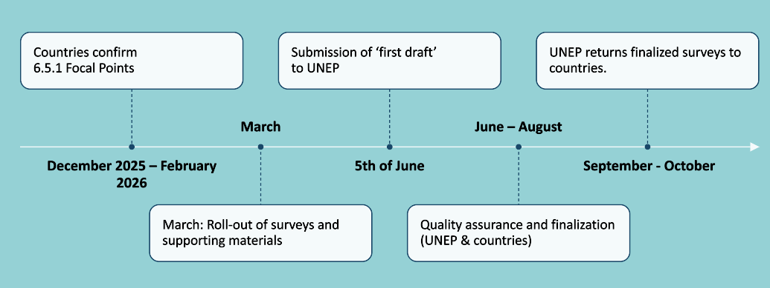Figure 2 - Timeline for reporting 2026

AFTER SUBMISSION
SDG 6.5.1 Focal Points are encouraged to share the outcomes, advocate for resources and discuss the way forward with relevant decision-makers, making use of the country summaries available on the IWRM Data Portal.
The SDG 6 IWRM Support Programme offers technical and financial assistance to a limited number of countries in developing an IWRM Action Plan or similar (Stage 2), and/or accessing financing for implementation (Stage 3). Interested countries can contact the Support Programme for more information (sdg6iwrmsp@gwp.org) and view existing IWRM Action Plans.
The SDG 6 IWRM Support Programme can also support work with regional bodies to co-develop assessments and products to help advance IWRM implementation at national and regional levels.
After each data collection round, UNEP and partners have the responsibility to: (a) make the results available via the IWRM Data Portal and prepare global status reports; and (b) report data to the UN Statistical Division for tracking progress towards the SDGs.

ANNEXES

ANNEX 1: SUMMARY OF OPTIONAL SUPPORTING MATERIAL
The following table provides a summary of optional resources that the Focal Point and colleagues may wish to pick and choose from, should they require further information, guidance, or tools. It is not necessary to read all these documents to successfully complete the 6.5.1 survey.
All documents are available via the IWRM Data Portal’s ‘data collection’ page.
Materials |  | Description | Languages*
Support to completing the survey
Survey Overview | One page overview |  |  | All
Calculation Template | Supports correct calculation of section and indicator scores. |  |  | All
Gender checklist | Checklist to support discussion on status of gender mainstreaming in WRM for the completion of survey question 2.2d. Please share the checklist with the Help Desk if it has been used by your country. |  |  | All
Stakeholder Consultation and Communication
Country Summaries |  | 2-page visual summaries of results from 2017, 2020 and 2023 per country. |  | All
Stakeholder Consultation Manual |  | Further information and guidance on suggested stakeholder consultation processes for SDG 6.5.1 reporting  Annex 1 – Online IWRM Survey Tool  Annex 2 – Example Workshop Agenda  Annex 3 – Example Facilitator ToR |  | All
SDG 6.5.1 Reporting Training |  | Self-paced, free, online course (4-6 hrs commitment) |  | EN, ES, FR
* All materials are available in English, French, Spanish, Arabic, Portuguese, Russian, and Chinese, unless stated otherwise.

ANNEX 2: 6.5.1 QUESTION LINKS TO OTHER SDG TARGETS
Involvement of other SDG indicator Focal Points is recommended for the following questions.
Survey question | Link to SDG target
1.2c, 2.2e, 3.2d, 4.1c | Transboundary questions linked to SDG indicator 6.5.2.
2.2b local level public participation | 6.b: Support and strengthen the participation of local communities in improving water and sanitation management.
2.2d gender in laws/plans or similar | Question A14.a in the GLAAS survey. 5.5: Ensure women’s full and effective participation and equal opportunities for leadership at all levels ... in political, economic and public life.
3.1a national monitoring of water availability | 6.4: By 2030, substantially increase water-use efficiency across all sectors and ensure sustainable withdrawals and supply of freshwater to address water scarcity and substantially reduce the number of people suffering from water scarcity.
3.1b sustainable and efficient water use management
3.1c pollution control | 6.3: By 2030, improve water quality by reducing pollution, eliminating dumping and minimizing release of hazardous chemicals and materials, halving the proportion of untreated wastewater and substantially increasing recycling and safe reuse globally.
3.1d management of water-related ecosystems | 6.6: By 2020, protect and restore water-related ecosystems, including mountains, forests, wetlands, rivers, aquifers and lakes.
3.1e management instruments to reduce impacts of water-related disasters | 11.5: By 2030, significantly reduce the number of deaths and the number of people affected and substantially decrease the direct economic losses relative to global gross domestic product caused by disasters, including water-related disasters, with a focus on protecting the poor and people in vulnerable situations.

ANNEX 3: SURVEY DIFFERENCES BETWEEN ROUNDS
2017 | 2020 | 2023 | 2026
Qs 1.2d & 2.2f: sub-national laws and institutions respectively, for federal countries only. | The revised questions 1.2d & 2.2f were opened to all countries, acknowledging that many countries have sub-national regulations and authorities, even if the countries are not federal. | As per 2020. | As per 2023.
Qs 2.1e, 2.2c & 2.2d: gender at national, sub-national and transboundary levels. | These three questions were merged into a single question 2.2d. In 2017, most countries reported the same or similar scores at each level, so three questions did not add significant value. The merging of these three questions created space for two additional questions (see below). | As per 2020 | As per 2023.  Clarifications to the thresholds and guidance text for questions 2.2c and 2.2d were added.
- | New question 2.2c on vulnerable groups. This captures an element of stakeholder participation which is important in the context of ‘leave no-one behind’ – one of the key principles of Agenda 2030. | As per 2020.
- | New question 4.2d on sub-national or basin budgets for IWRM elements, acknowledging the importance of funding being available at more ‘operational’ levels. | As per 2020. | As per 2023.
- | - | Additional free-text field on “climate change considerations” for questions 1.1c, 2.1b, 2.1e, 3.1e, and 4.1b. | Rather than being embedded in a particular question in each section, this question now comes at the end of each section, so that it can address all aspects of that section (IWRM dimension). In addition, countries are asked to choose one of 6 implementation categories to quantify the implementation level.
- | - | - | Added free text field "Changes since 2023 reporting” to help countries clarify changes from 2023 to 2026.
For clarity, minor amendments have also been made to: some threshold descriptions; guidance in the free-text fields; glossary (Annex A of Survey).

The standardised United Nations Statistical Division (UNSD) Metadata Sheet for 6.5.1 may be relevant for NSOs.

